Document with images
  - Four embedded photos with captions, between paragraphs of text.
JPEG remains the workhorse for photographs. It uses lossy compression that throws away detail the eye is unlikely to miss, which keeps files small but means every re-save loses a little quality. PNG is lossless and supports transparency, which makes it the usual choice for screenshots, logos and interface graphics, at the cost of larger files for photographic content.

Figure 1. Generated landscape, 1600 × 1000 JPEG.
A video file has two layers that are easy to confuse. The container, such as MP4, MOV, WebM or MKV, is the box that holds the streams, timing information and metadata. The codec, such as H.264, HEVC, VP9 or AV1, is the method used to compress the pictures inside the box. Two MP4 files can contain completely different codecs, and a player that handles one may refuse the other.

Figure 2. Generated landscape, 1600 × 1000 JPEG.
Digital audio starts as a stream of samples, typically 44,100 or 48,000 per second for each channel. WAV files usually store those samples uncompressed, which makes them large but simple and lossless. MP3 and AAC use perceptual compression to shrink the same audio by a factor of ten or more while keeping it pleasant to listen to.

Figure 3. Generated landscape, 1600 × 1000 JPEG.
JSON has become the default language of web APIs. It is easy to read, maps naturally onto objects in most programming languages and supports nesting. Its simplicity also hides traps: very large numbers lose precision in JavaScript, duplicate keys are technically allowed, and a single missing comma makes the whole document invalid.
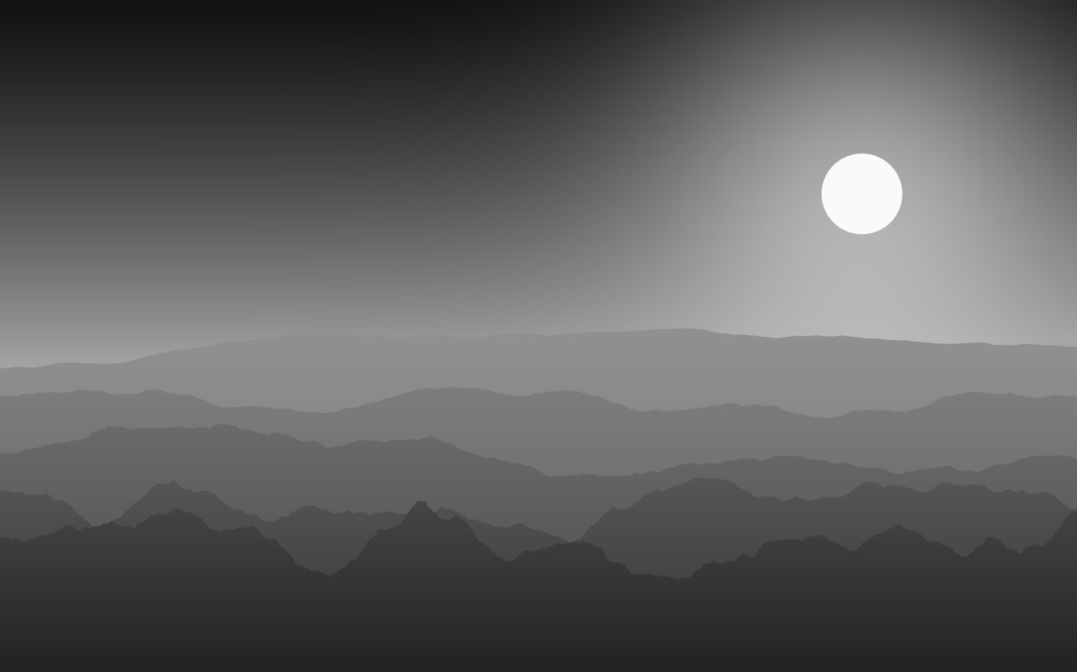
Figure 4. Generated landscape, 1600 × 1000 JPEG.

